TASK-2 REPORT

- Students table
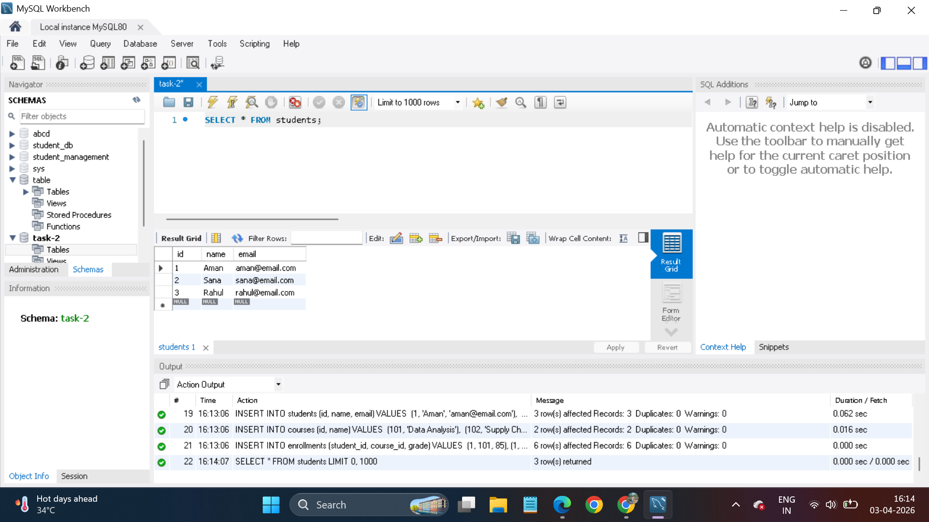

- Courses table
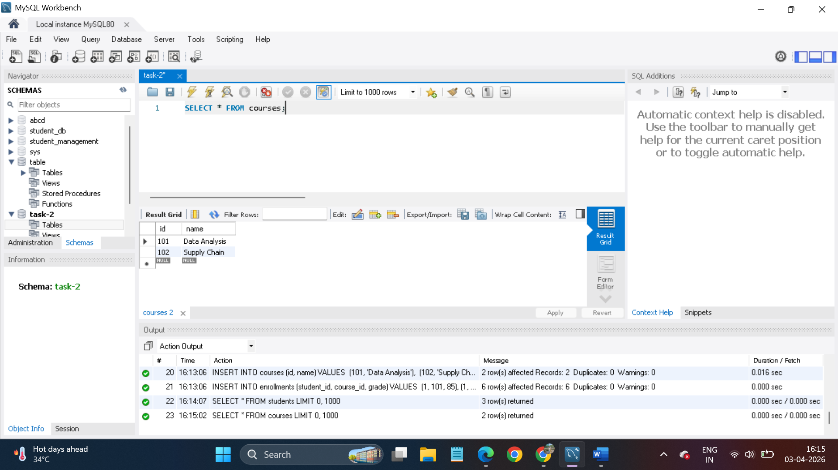

- Enrollment table
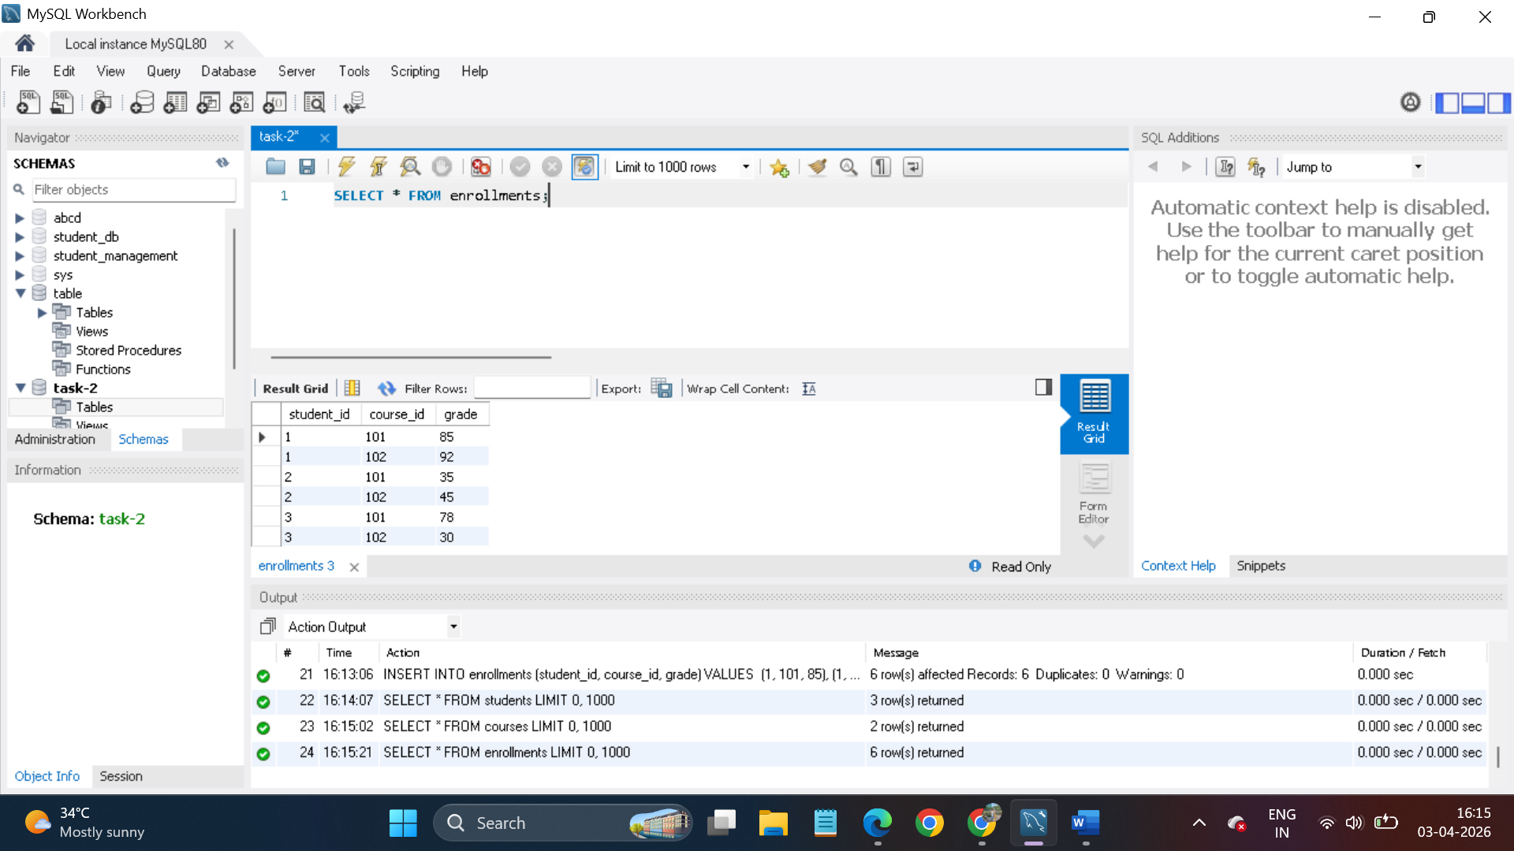

- Students in each course: The query returns a combined list of student names alongside the specific courses they are enrolled in by joining the students and courses tables
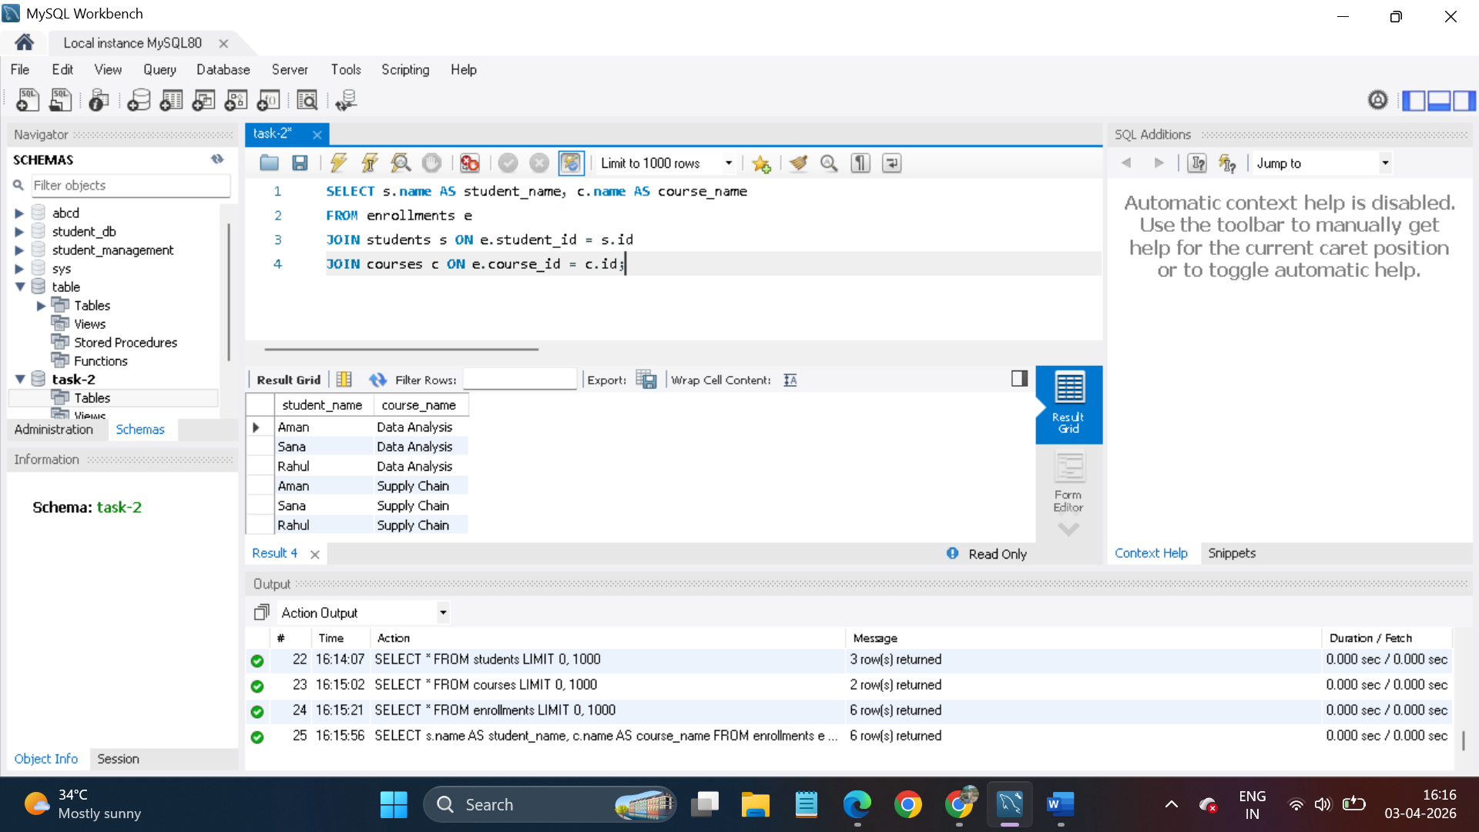

- Average grade per course: This result displays the mean score for each subject, such as "Data Analysis" or "Supply Chain Management," by aggregating all student grades within those categories .
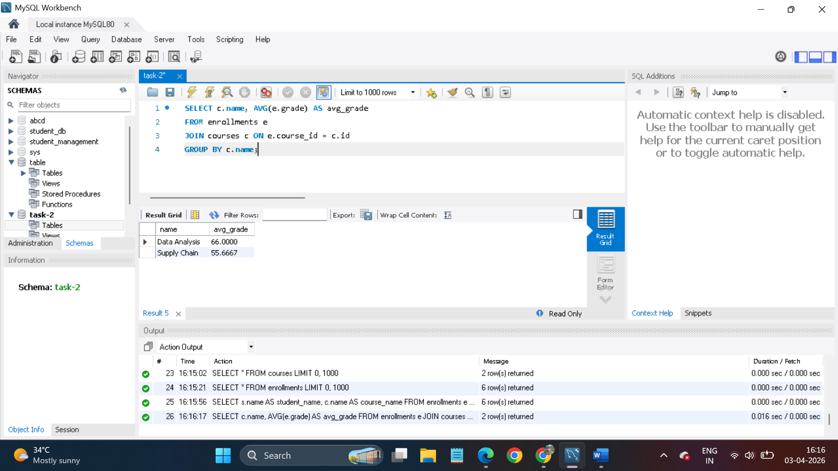

- Top 3 students: This list identifies the three individuals with the highest calculated grade point averages across the entire database .
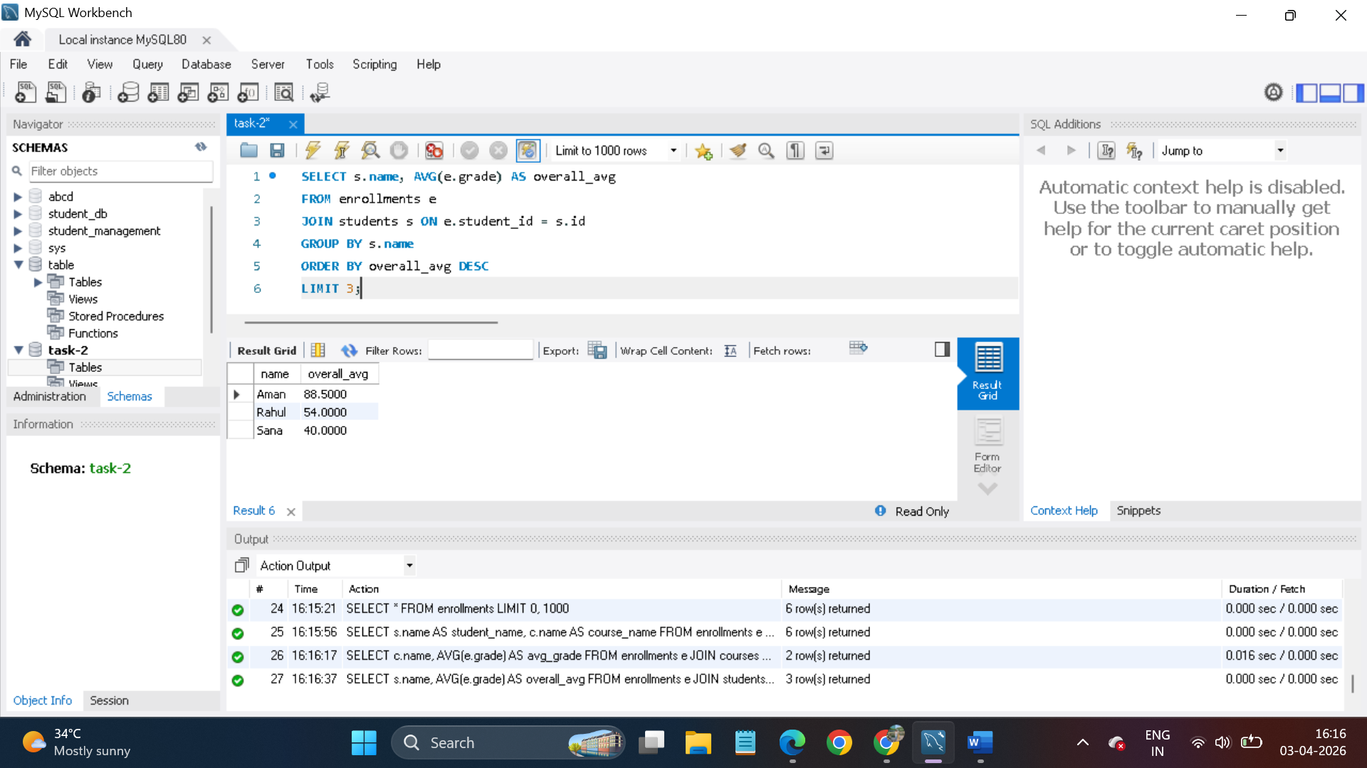

- Failed students count: The result provides a single numerical value representing the total number of unique students who received a grade lower than 40.
